Proposed Solution
ShopEZ — MERN Stack E-commerce Application

Phase: Project Design Phase
TEAM ID : SWUID2026207177
Classification: Project Documentation — For Academic Submission
Proposed Solution
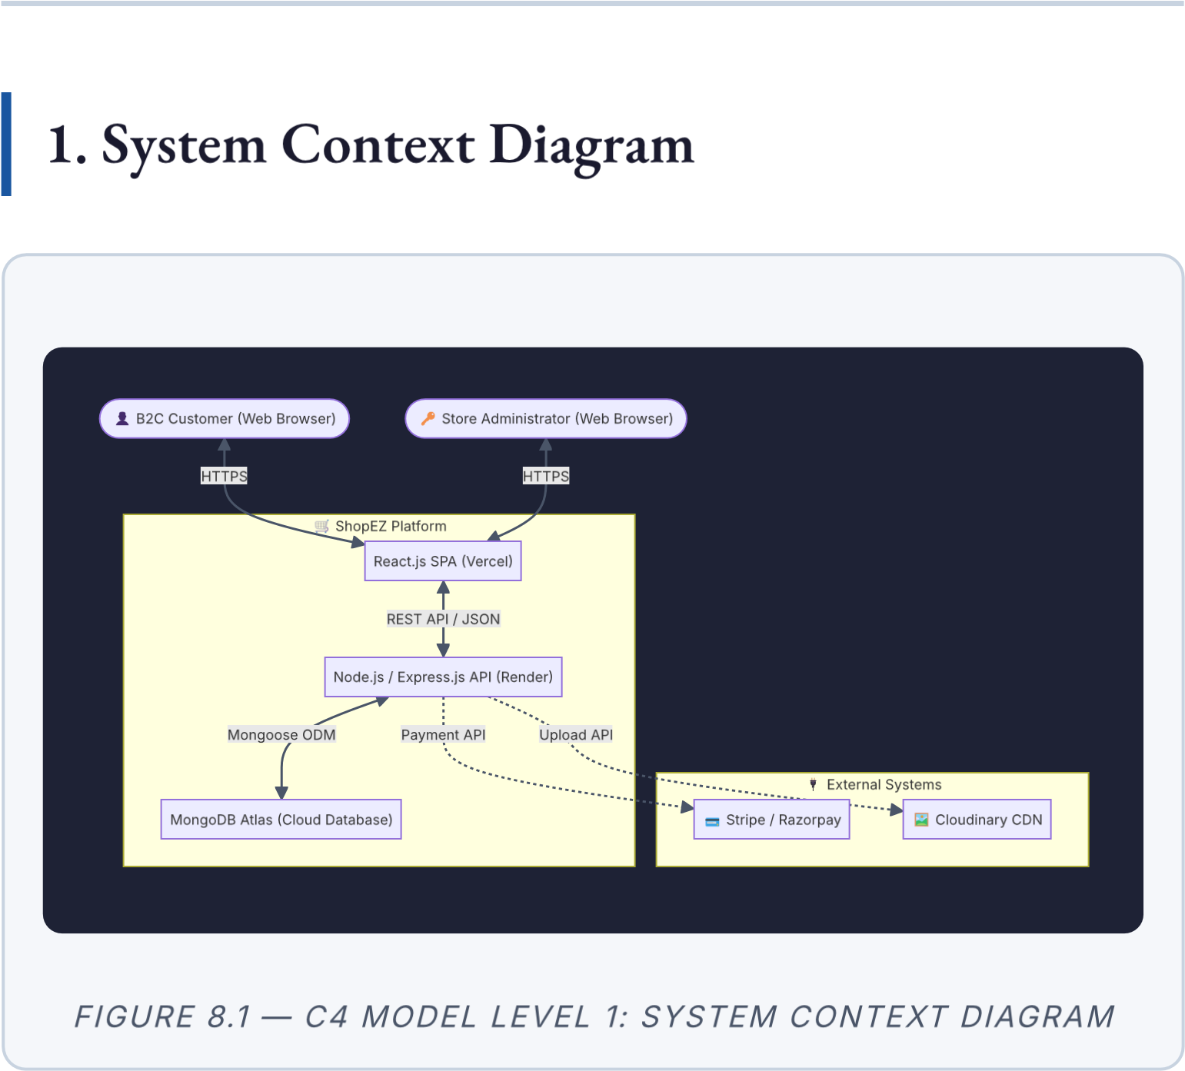

2. Solution Parameters
S.No. |  | Parameter | Detailed Description
 | 1 | Problem  Statement | Customers require a secure, fast, and intuitive platform to discover and purchase
4 | Social Impact  / Customer  Satisfaction | Delivers a reliable, transparent purchasing process building consumer trust through secure payment integration and clear order tracking. Empowers small business operators with accessible analytics, enabling data-
items online. Administrators require a centralised, efficient tool to manage product inventory, monitor sales performance, and fulfil orders. The core gap is the absence of a unified, modern, customisable e-commerce solution accessible without prohibitive SaaS subscription costs.
2 |  | Solution  Description | A fully responsive Single Page Application (SPA) built on the MERN stack. The platform provides: (i) a customer-facing storefront with robust product discovery, persistent cart, and guided checkout; and (ii) an administrator panel with inventory management, order fulfilment, Cloudinarypowered image uploads, and sales analytics dashboards. Payment processing is delegated to PCI-DSS compliant gateways (Stripe / Razorpay).
 | 3 | Novelty /  Uniqueness | Decoupled architecture with independently deployable frontend and backend;
MongoDB-backed cross-device cart persistence; Cloudinary dynamic image transformations on CDN delivery; stateless JWT authentication enabling horizontal API scaling.
S.No. |  | Parameter | Detailed Description
 |  |  | driven inventory decisions and improved customer service.
 | 5 | Business  Model  (Revenue  Model) | Primary: direct sales margin on products. Secondary: premium product placement / featured listing slots; percentage-based commission for future multi-vendor
configuration; shipping and handling fee collection on high-volume orders.

3. High-Level Feature Summary
Feature Category | Key Capabilities
Authentication &  Security | JWT + Bcrypt; HTTP-only cookie sessions;  RBAC (User / Admin)
Product Discovery | Full-text search; Category, Price, Rating filters;  Sorting options
Shopping  Experience | Persistent cross-device cart; Real-time total calculation; Stock validation
Checkout & Payment | 3-step wizard; Stripe / Razorpay integration;  Invoice generation
Order Management | Order history (customer); Fulfilment status tracking (admin)
Product Reviews | Verified purchase reviews; Aggregate rating recalculation
Admin Operations | Product CRUD; Category management;  Cloudinary image upload
Admin Analytics | Revenue charts; Order volume metrics; User growth indicators
ShopEZ MERN E-commerce Application · Project Design Phase · Proposed Solution

